**3. Morphological Analysis using NLTK**

**Aim:**  
To perform morphological analysis using the NLTK library.

**Algorithm:**

1. Import the necessary NLTK modules.
2. Tokenize the input text into words.
3. Perform stemming or lemmatization for analysis.

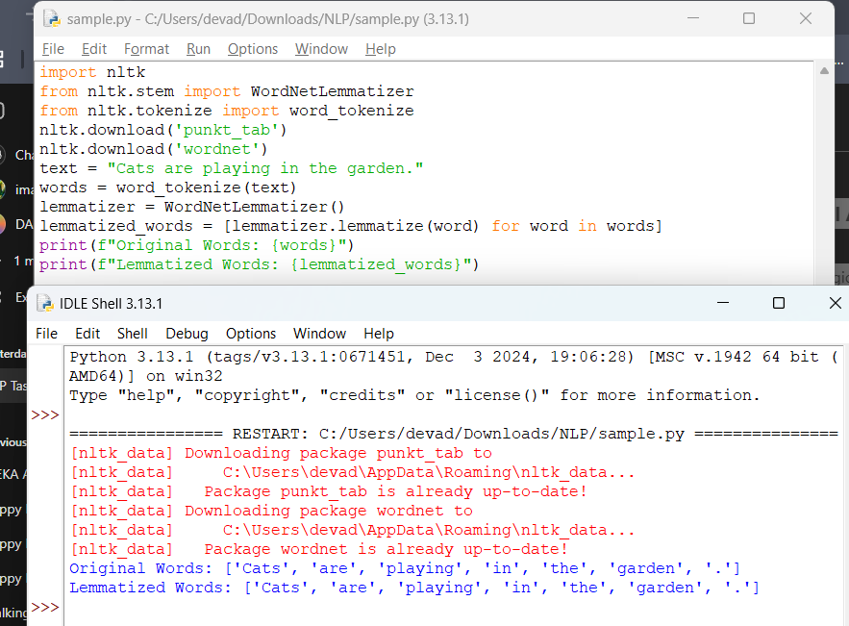

**Result:**  
Morphological analysis is performed using lemmatization.